North

South

West

East

Get Left

Drop Left

Get Right

Drop Right

Use Left

Use Right

**Special**

Look

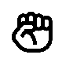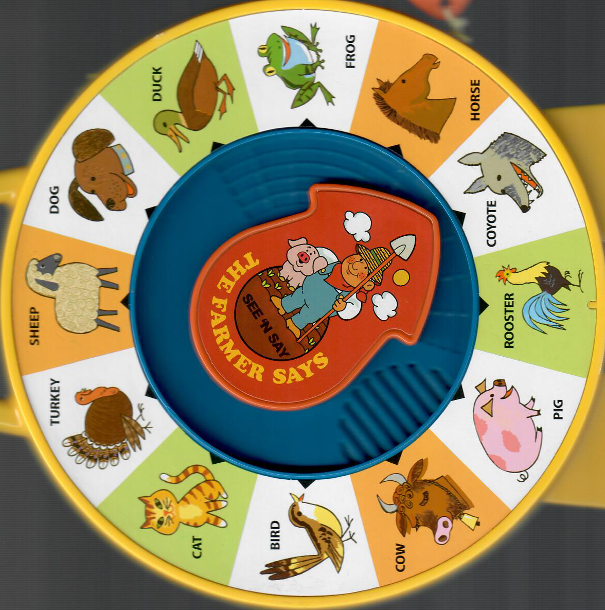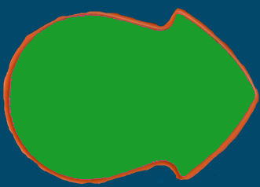

Audio Adventures

Vending

Break

Cubes

Lab

1stHall

Lobby

Conference

2ndLanding

2ndHallWest

2ndHallEast

Wenxiao

3rdLanding

Engineering

Devops

**wrench \***

**soda \***

**quarter \***

**WIN**

**watergun**

**dime \***

**nickel \***

**k8s \***

Must deposit all 3 coins

north: any deposited coins are moved to random rooms

look to drop

Use wrench to fix water

Use watergun to fill gun

Plant takes two waterings. Over water and it withers. Use a free hand to climb (up or down)

Use dime to drop

Use watergun to drop

Use wrench to drop

Use k8s to drop

**Eric**

**Topher**

**Brockhaus**

**?**

**?**

**Al**

**Russ**

**Wenxiao**

**Donald**

**Larry**

**Alex**

**Mike**

**Brad**

**?**

**Lauren**

**N**

**S**

**W**

**E**

**Purple: suggested voice**

Use k8s to transport

**object *: object starts hidden**